**Introduction:**

**1.Project Overview:**

The purpose of this document is to analyze and define the requirements for the CRM application tailored for jewel management. This system will facilitate customer management, inventory tracking,sales monitoring, and user role administration.

**2.Purpose:**

* Clearly defines the necessary features and overall product vision.
* Identifying and clarifying stakeholder expectations for the product.
* Having requirements in place helps avoid disagreements and misunderstandings during the development and testing stages of the project.
* Ensures the final software product adheres to the specified requirements, thus avoiding scope creep.

**Customer Journey Map**

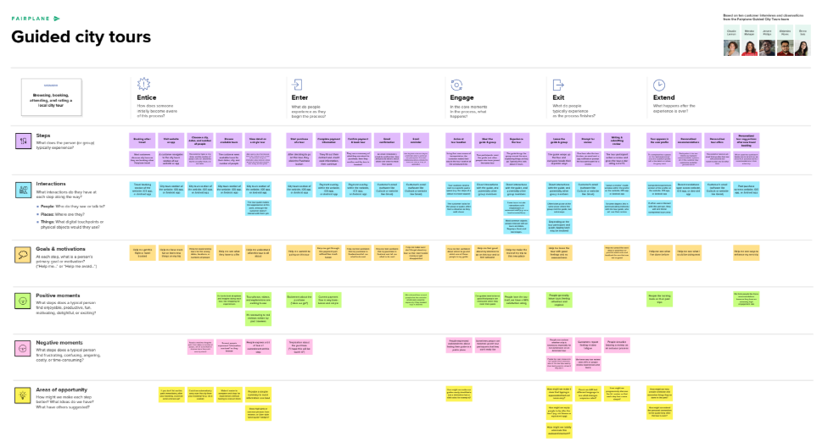

**Project Design Phase-II**

**Data Flow Diagram &amp; User Stories**

|  |  |
| --- | --- |
| Date | 31 January 2025 |
| TEAM ID | LTVIP2025TMID19428 |
| Project Name | CRM Application for jewel management |
| Maximum Marks | 4 Marks |

**Data Flow Diagrams:**

A Data Flow Diagram (DFD) is a traditional visual representation of the information flows within a system. A neat and clear DFD can depict the right amount of the system requirement graphically. It shows how data enters and leaves the system, what changes the information, and where data is stored.

**Example (Simplified)**

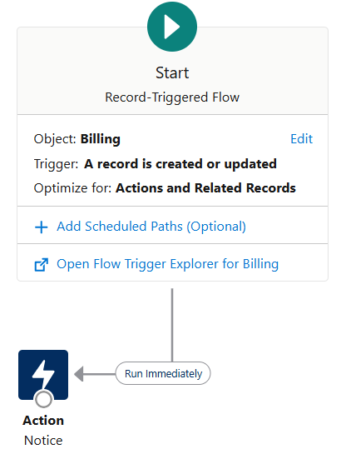

**User Stories:**

|  |  |  |  |  |  |  |
| --- | --- | --- | --- | --- | --- | --- |
| **User Type** | **Functional**  **Requirement**  **(Epic)** | **User**  **Story**  **Number** | **User Story/Task** | **Acceptable criteria** | **Priority** | **Release** |
| Customer(Mobile user) | Registration | USN-1 | As a user, I can register for the application by  entering my email, password, and confirming  my password. | I can access my account /  dashboard | High | Sprint-1 |
| Customer(Mobile user) | Registration | USN-2 | As a user, I will receive confirmation email  once I have registered for the application | I can receive confirmation email &amp; click confirm | High | Sprint-1 |
| Customer(Mobile user) | Registration | USN-3 | As a user, I can register for the application  through Facebook | I can register &amp; access the  dashboard with Facebook  Login | Low | Sprint-2 |
| Customer(Mobile user) | Registration | USN-4 | As a user, I can register for the application  through Gmail | As a user, I can register for the application through Gmail. | Medium | Sprint-1 |
| Customer(Web user) | Login & Dashboard | USN-5 | As a user, I can log into the application by entering email &amp; password | As a user, I can log into the application by entering my email & password. | High | Sprint-1 |

**Project Design Phase-II**

**Solution Requirements (Functional &amp; Non-functional)**

|  |  |
| --- | --- |
| Date | 31 January 2025 |
| TEAM ID | LTVIP2025TMID19428 |
| Project Name | CRM Application for jewel management |
| Maximum Marks | 4 Marks |

**Functional Requirements:**

|  |  |  |
| --- | --- | --- |
| **FR No.** | **Functional Requirement (Epic)** | **Sub Requirement (Story / Sub-Task)** |
| FR-1 | User Management | Admin login/logout, User roles & permissions, Staff account creatiot |
| FR-2 | Jewelry Inventory Management | Add/edit/delete jewelry items, Categorization (Gold, Diamond, etc.), Stock level alerts |
| FR-3 | Customer Management | Customer profile creation, Purchase history tracking, Customer inquiries & feedback |
| FR-4 | Order & Sales Management | Invoice generation, Payment tracking, Order status updates |

**Non-functional Requirements:**

|  |  |  |
| --- | --- | --- |
| **NFR No** | **Non-Functional Requirement** | **Description** |
| NFR-1 | Usability | The system should have a user-friendly interface for admins. |
| NFR-2 | Security | Implement role-based access and encryption for sensitive data |
| NFR-3 | Reliability | The system should handle high transaction volumes without failure |
| NFR-4 | Performance | The system should process queries within 2 seconds |
| NFR-5 | Availability | The application should have 99.9% uptime |
| NFR-6 | Scalability | The system should be able to handle growing inventory and users |

**_**

**Project Design Phase-II**

**Technology Stack (Architecture &amp; Stack)**

|  |  |
| --- | --- |
| Date | 31 January 2025 |
| TEAM ID | LTVIP2025TMID19428 |
| Project Name | CRM Application for jewel management |
| Maximum Marks | 4 Marks |

**Technical Architecture:**

**Table 1:**

|  |  |  |  |
| --- | --- | --- | --- |
| **S.No** | **Component** | **Description** | **Technology** |
| 1. | User Interface | How user interacts with application e.g. Web UI, Mobile App, Chatbot etc. | HTML, CSS, React Js etc. |
| 2. | Application Logic-1 | Logic for a process in the application | Java / Python |
| 3. | Application Logic-2 | Logic for a process in the application | IBM Watson STT service |
| 4. | Application Logic-3 | Logic for a process in the application | IBM Watson Assistant |
| 5. | Database | Data Type, Configurations etc. | MySQL, NoSQL, etc. |
| 6. | Cloud Database | Database Service on Cloud | IBM DB2, IBM Cloudant etc. |
| 7. | File Storage | File storage requirements | IBM Block Storage or Other Storage  Service or Local Filesystem |
| 8. | External API-1 | Purpose of External API used in the application | IBM Weather API, etc. |
| 9. | External API-2 | Purpose of External API used in the application | Aadhar API, etc. |
| 10. | Machine Learning Model | Purpose of Machine Learning Model | Object Recognition Model, etc. |
| 11. | Infrastructure (Server / Cloud) | Application Deployment on Local System / Cloud  Local Server Configuration:  Cloud Server Configuration : | Local, Cloud Foundry, Kubernetes, etc. |

**Table 2:**

**Application Characteristics:**

|  |  |  |  |
| --- | --- | --- | --- |
| **S.NO** | **Characteristics** | **Description** | **Technology** |
| 1. | Open-source Frameworks | List the open-source frameworks used | Technology of Opensource framework |
| 2. | Security Implementations | List all the security / access controls implemented, use of firewalls etc. | e.g. SHA-256, Encryptions, IAM Controls, OWASP etc. |
| 3. | Scalable Architecture | Justify the scalability of architecture (3 – tier, Micro-services) | Technology used |
| 4. | Availability | Justify the availability of application (e.g. use of load balancers, distributed servers etc.) | Technology used |
| 5. | Performance | Design consideration for the performance of the application (number of requests per sec, use of Cache, use of CDN’s) etc. | Technology used |

**CONCLUSION:**

The CRM application for jewel management aims to streamline business operations, enhance customer engagement, and improve sales tracking. The defined requirements ensure a robust, scalable, and secure system tailored to the needs of the jewelry business

**THANKYOU SMARTBRIDGE**

**B.NAGA SAI LAKSHMI KAMALA**

**TEAM LEADER**